COVID-19 nosocomial infection in Dental Settings: Wuhan Report

The data were collected in the School and Hospital of Stomatology, Wuhan University, Wuhan China during COVID-19 outbreak in Wuhan, where COVID-19 started in Jan 2020. The hospital provided dental care to around 890,000 patients in 2019 and has 1098 staff members and 828 students.

Risk of nosocomial infection in this hospital

- Incidence of staff COVID-19 infection when routine dental procedures were performed with regular PPE (medical masks and gloves only), 1500 – 4000 walk-in patients were seen daily (figure 2). The data were collected during Dec 30, 2019 – Jan 23, 2020 before the whole city in total lockdown on Jan 23, 2020. Widespread community transmissions might have been happening among the 11 million residents in Wuhan during this period of time.

In total, 9 people out of 1098 + 828 staff and students (3 dentists, 3 dental assistants, 2 administrative staff and 1 postgraduate student) were confirmed to have COVID-19. The authors attributed the limited transmission to wearing regular PPE of masks and gloves. For example, 2 nurses (RDA) were infected in the department of prosthodontics with 51 staff members (Table). The clinic settings were similar to the main clinic at U of M, frequent interactions among staff members and between patients were expected. It is unknown if and how many patients got infected as result of the dental treatment in this hospital during this period of time, but the risk of cross transmission among staff members seemed low when regular PPEs were used.

Staff members with flu like symptoms or in close contact with a case were asked to stay home.

No cases were reported in the Department of Periodontics, where multiple hygienists were working along with periodontists in this department and Cavitron units were routinely used for SPT and SRP.

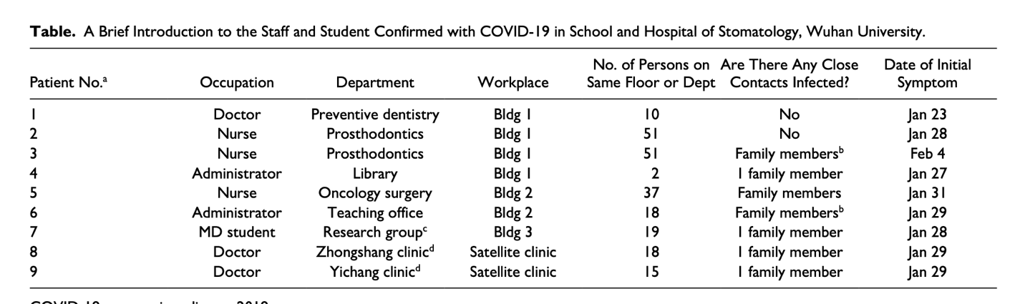

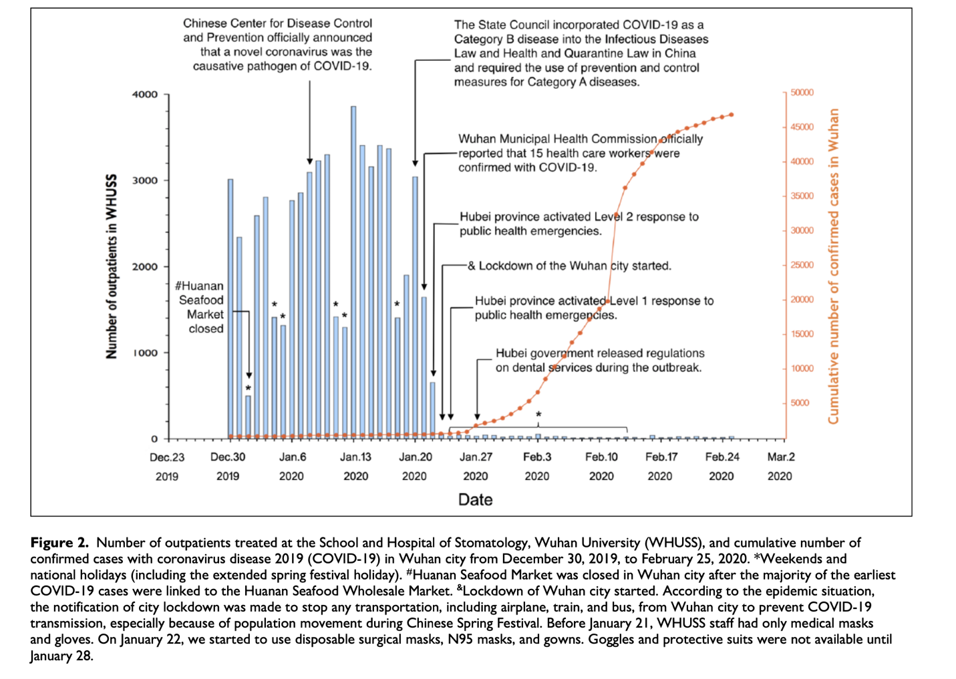

- No new COVID-19 cases after new protection measures were implemented for dental emergencies. Data were collected during Jan 24-Feb 25, 2020. As cases of COVID-19 soared exponentially in Wuhan (figure 2), non-emergency dental services were suspended in this hospital, new protection measures were implemented as shown on figure 3, enhanced PPE including N95 masks, face shields, goggles and gowns were used for treatment of emergency patient.

More than 700 patients were seen by 169 in this hospital for dental emergency since Jan 24, no further COVID-19 cases were reported among the staff.

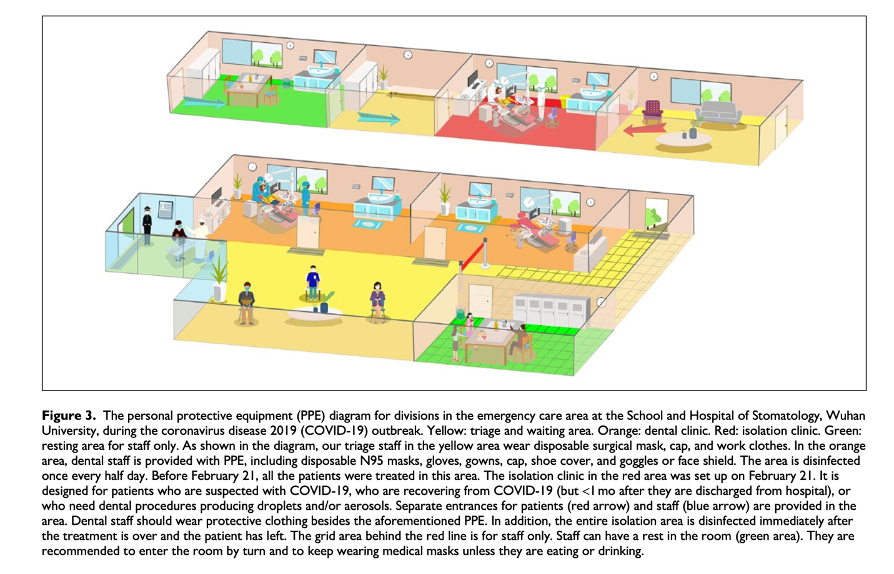

Recommendations in dental settings

- Patient screening: temperature, medical status, history of contact and travel;
- 14 days of quarantine before a patient can be seen if the patient has been to epidemic regions;
- Dental treatment of COVID-19 patients who have been treated for COVID-19 and discharged from hospital should be postponed until 1 months after they are dismissed from hospital;
- Patient temperature checking before entering the hospital, patient with fever (> 37.3°C) to be referred to a designated fever clinic;
- Patients and accompanying persons provided with masks once entering the hospital;
- Preoperative antimicrobial mouth rinse prior to oral examination;
- Avoiding or minimizing aerosol generating procedures;
- Extraoral dental radiographs preferred as intraoral x rays may stimulate secretion of saliva and coughing;
- Face shields and goggles are essential when using high or low speed handpieces with water spray;
- Rubber dams and high-volume saliva ejectors to be used for aerosol generating procedures;
- Aerosol generating procedures to be scheduled at the end of day, followed by thorough cleaning and disinfection. Alternatively, the procedure should be performed in an isolated or well-ventilated room or a negative pressure room if available.
- Patient with life-threatening oral and maxillofacial injuries to be admitted to the hospital, chest CT instead of regular time-consuming RT-PCR test to rule out COVID-19.

